CMSC 447

Software User Manual (SUM)

1 Scope 3

1.1 Identification 3

1.2 System overview 3

1.3 Document overview 4

1.3.1 Version Modification 4

2 Referenced documents 4

3 Software summary 5

3.1 Software application 5

3.2 Software inventory 5

3.3 Software organization and overview of operation 6

4 Access to the software 10

4.1 First-time user of the software 10

4.1.1 Equipment familiarization 10

4.1.2 Access control 12

4.2 Initiating a session 12

4.3 Stopping and suspending work 12

5 Processing reference guide 12

5.1 Capabilities 12

5.2 Conventions 13

5.3 Messages 13

6 Signatures 13

# Scope

## Identification

This project is to be a web application which when implemented will allow a user to input preferences into a questionnaire and top locations will then be outputted onto a map. When first accessing the webpage, the user will begin with the “login page.” From the login page, a user can access a “create an account page” or after authentication access their “homepage.” The homepage will allow the user to modify their account information from a “modify account page,” as well as allow the user to see the “map” and access the “questionnaire,” which are defined below.

The “questionnaire” refers to the portion of the project where the user inputs these preferences. This will be accessed from the homepage into a “questionnaire page.” The “ratings” will refer to the numerical input from a user in which they determine which statistics have a higher preference. The “statistics” refer to the set of data that our project will be accessing. The “map” refers to the portion of the project which is the visualization of data. The map is initially displayed from the homepage, but will initially be empty, and be modified as the user takes the questionnaire. After the user completes the questionnaire the map is referenced to be an “updated map” with the continuing definitions being components of the map. The map may also have markers which will be referred to as “pins.” The pins will allow the user to see an image of the location referred to as the “pin image.” In some cases where an image is not available, or if there is additional implementation, a pin may allow the user to see descriptive information on the location which will be referred to as the “pin information.”

These unique pages correspond to the pages that the user will be able to access. The user accessible pages will include the login page, create account page, modify account page, questionnaire page, and homepage. The user accessible pages correspond to the developed CSCI pages. These pages each represent unique components whose functionality behaves independent of the other parts of the system.

## System overview

The goal of this project is to create a web application which will allow a user to create an account, and from such account be able to evaluate different statistical values such that a list of locations within the United States will be outputted to the user which correlate to the user input. With the list, a map should be presented with pins that correlate to the location and can then be further expanded to output a location image or description.

A SQL database will be used for maintaining the user accounts. Along with this we expect to be using third party software for our output. This would include the use of GoogleMaps for our map output, Flickr for our image outputs, and Wikipedia for a description output. Further third-party software will be expanded in this section as seems fit throughout the project.

This system intends to allow users the ability to find a location which corresponds to their location specific statistics. These statistics were obtained for the United States Census Bureau. These statistics ought to reflect the normal requirements of somebody moving to a new location. The intention of this system is to allow the user the ability find a location within the United States which the user would prefer.

Furthermore, this system has also implemented a basic login procedure. This would allow for further expansions in design and eventual further content. There are multiple non-implemented goals with the system for further expansion from this functionality. This would include the ability to turn the system into a social media platform where users would be able to share their top locations with other users. Other functionality included the implementation of administrative users. These administrators would interact with the other social media users and can modify user accounts, as well as look up the search results of the other users.

## Document overview

The goal of this document is to explain to a user the procedure for which they will use the developed web application. This should give the user basic information on their progression through the different web pages. This document will also serve as a means for the user having an insight into the naming scheme of the different webpages. The different progressions that a user can possibly make throughout the web application should correspond to the requirements for the system. The page naming scheme can be found within the Software Design Description.

Furthermore, this document intends to report to a user the functionality of this system. The functionality of the system is described in the basic procedures of what a user can do throughout the system. Finally, this document intends to allow the user basic information regarding the debugging procedures within the system. This includes current bug reports, as well as error messages that may be presented to the user. These include the procedures that the user should follow such that they can move throughout the system. These procedures are intended to follow that of a normal web application such that a user could successfully use the system using their previous internet knowledge.

**1.3.1 Version Modification**

Version 1.0: Original Document

This is the completed rough draft of the User manual. Waiting on screen shots to include in the document as visual descriptions.

Version 2.3: Updated numbering to match other documentation. Updated sections 1.1-1.3

Version 2.4: Final draft. Updated for latest code changes.

# Referenced documents

The following are referenced documents throughout this document and include the common acronym for referencing the document:

SRS- Software Requirements Specification

SDD – Software Design Description

STD – Software Test Description

# Software summary

## Software application

The goal of this system is to create a web application which will allow a user to create an account, and from such account be able to evaluate different statistical values such that a list of locations within the United States will be outputted to the user which correlate to the user input. With the list, a map should be presented with pins that correlate to the location and can then be further expanded to output a location image or description. These statistics correspond to statistics given by the Census Bureau. Additionally, the application maintains a login service which will allow the user to have a username, password, avatar, and an about me textbox.

## Software inventory

Guidelines for setting up the environment can be further found within the SETUP README file as well as in the STD. The following items will need to be installed and setup for this system: Python3, Visual C++, and MYSQL. Additionally, there will be a description for how to start the web application. Each will then have a further description on how to install below.

To run the backend code Python 3 will need to be installed. This will just require running the python-3.6.5-amd64.exe. This can be found in the Programs directory. In the first stage of the installation, you will need to choose the “Add to Path” checkbox option. Further instructions for the Python Installation can be found within the SETUP README file found in the home directory.

Most machines already have an installation of Microsoft Visual C++. To verify if your machine has Microsoft Visual C++ installed simply search for the application in your application search bar. If Microsoft Visual C++ is not installed on the machine simply run the vc_redist.x64.exe found in the Programs directory. Further instruction for the Microsoft Visual C++ Installation can be found within the SETUP README file found in the home directory.

MYSQL will be required to run the login database in the frontend, as well as the Census Bureau database in the backend. This install file is called mysql-installer-web-community-8.0.11.0.exe which can be found in the Programs directory. This will require a custom install of MYSQL. The following will need to be installed during the process.

1. MySQL Server

2. MySQL Workbench

3. MySQL Shell

4. MySQL Router

5. Connector/Python (3.6) 8.0.11

For help finding the hidden installation requirements directions are below:

1. MySQL Server is under the MySQL Servers folder

2. MySQL Workbench, Shell, Router are under the Applications folder

3. Python connector is in the MySQL Connectors folder. Make sure to get the Python 3.6 x64 connector

From here leave all settings as except the root password should be the default setting. Set the password to be "password" (without the quotation marks.) When asked for the Authentication Method, check the Legacy Authentication Method. Finally, open the program MySQL Workbench and double click on "Local instance MySQL Router and do the following:

1) When asked for the root password, enter "password" and click connect.

2) Click on the button in the toolbar that looks like two cylinders stacked on top of each other (If you hover over it should say create new schema) and call the new schema "project”. Further instructions for the MYSQL installation can be found within the SETUP README file.

Next is how to configure the backend environment. This will first require changing the PowerShell execution policy. To change the PowerShell execution policy. This can be done by opening PowerShell as Administrator and run the command:

"Set-ExecutionPolicy RemoteSigned"

Next to set up the virtual environment to run python code. This can be done with the following steps:

1) In PowerShell run "pip install virtualenv"

2) Then in the Group2Project folder, run "virtualenv venv/"

3) Then run "venv/Scripts/activate"

4) then run "pip install -r Code/requirements/base.txt"

5) then run "python Code/manage.py migrate"

Python code can now be executed using the command:

"python Code/manage.py runserver". Further instructions can be found in the SETUP README file.

This setup is for a windows environment. First, in a browser go to: https://nodejs.org/dist/v8.11.1/node-v8.11.1-x64.msi

Next, install node js 8.1.1 with the default options. From the root directory, enter the frontend directory. Open a Windows PowerShell by holding shift and right clicking. From the list of options, click the “open PowerShell window here.” From here run the following commands:

npm install

npm run

This first command will install the dependencies for the system. The second command will open the site. Afterwards the website may be reached from localhost:4200. Further instructions on the setup process can be found within the SETUP README.

## Software organization and overview of operation

The following will describe for the user how to use the developed system. The user will first connect to the login page of the system which is accessed through the localhost of a browser. The login page will be shown as below.

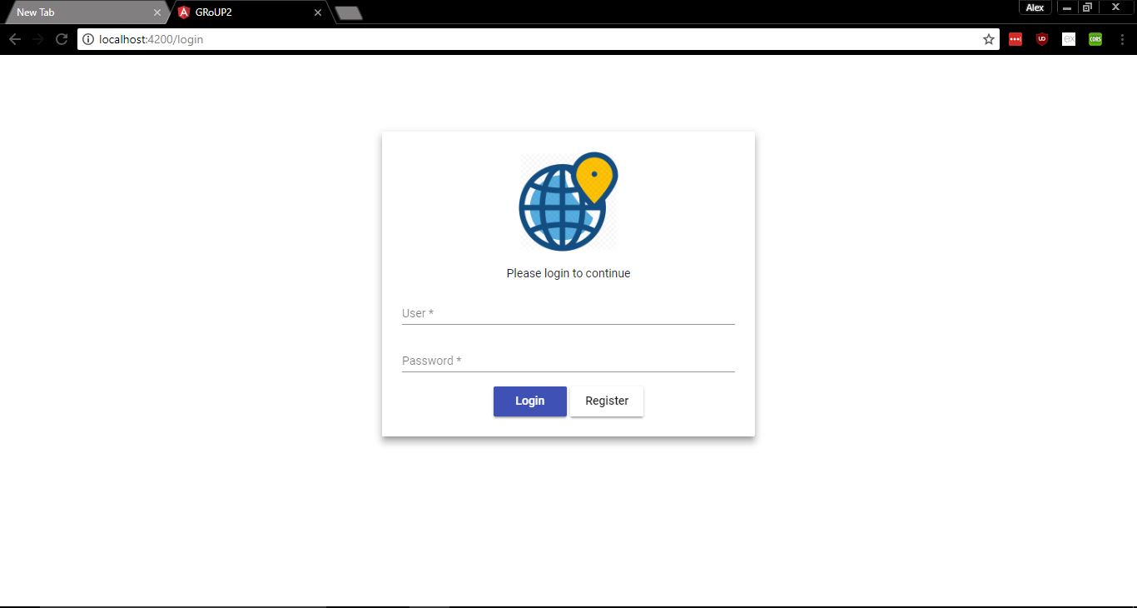

From here, assuming the user is a new user, they will click the create account button to access the create account page. The user will then fill the page with their desired username and password. The username is verified to be unique, and assuming this condition is met, which will send the user back to the homepage where they may login. Username and password fields must be entered and cannot be NULL. The create account page will be shown as below.

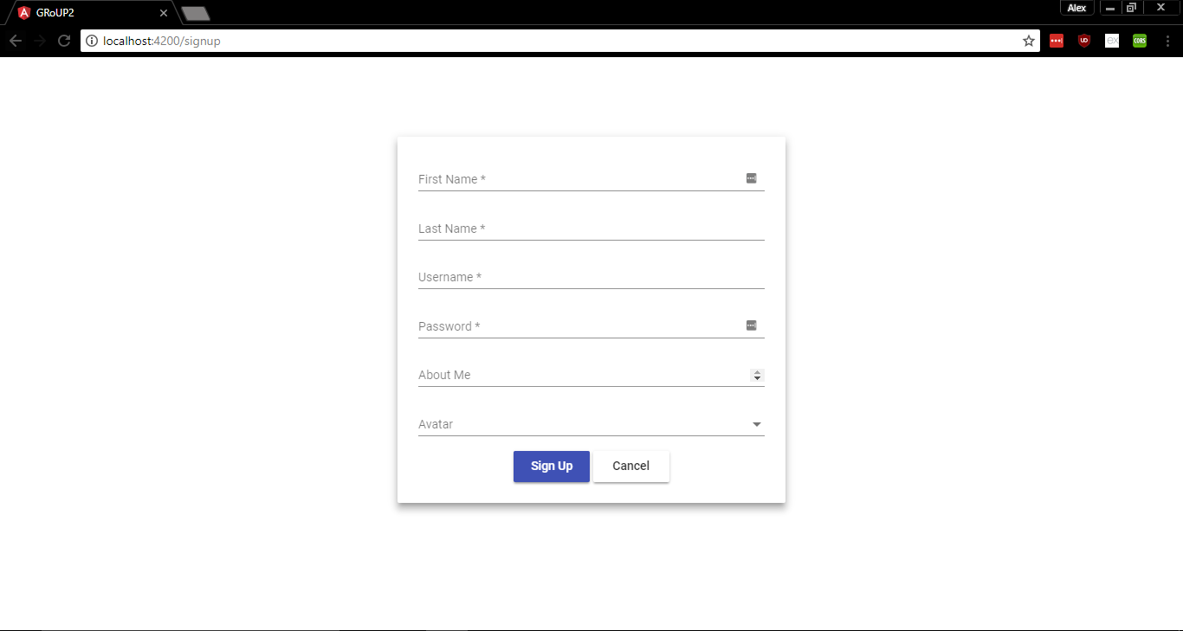

The user will then be sent to the homepage of the application. From here the user will view a map of the United States, as well as be able to access further pages. The pages include the survey page and modify account page. The user will click the buttons to access these pages. The homepage will be shown as below.

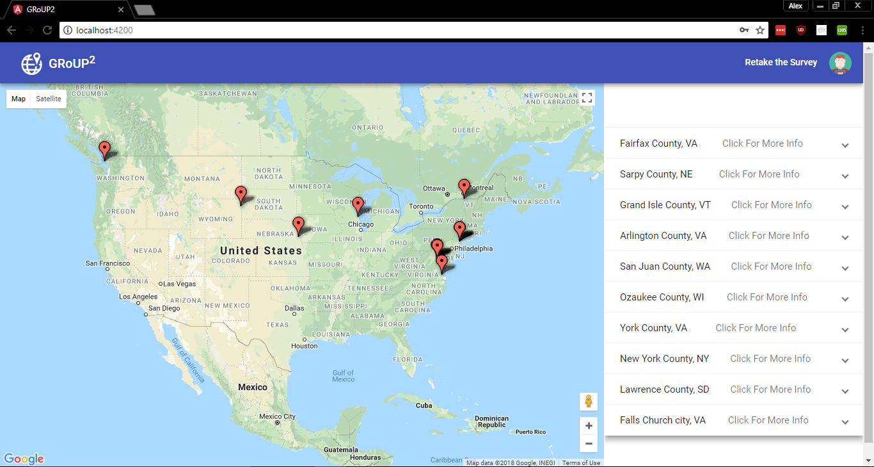

The modify account page allows the user to change info regarding their user account. The modifiable fields include the username, password, about me text, and the avatar. The new account information should be entered within their appropriate fields on the modify account page. If there is nothing entered within a field it is assumed that the user does not wish to change that account information. This also prevents the user from accidentally changing account information, as well as avoiding NULL password or usernames. The modify account page will be shown as below.

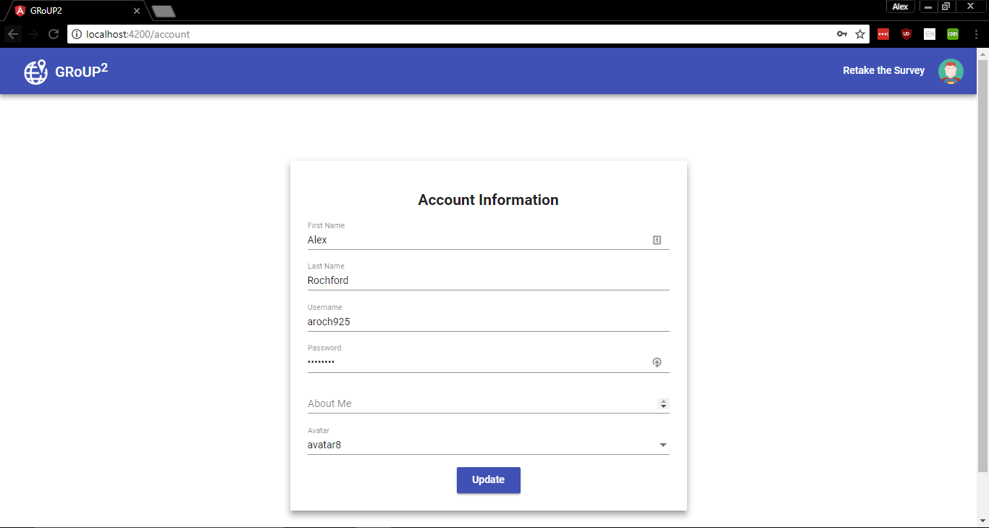 The survey page can be used to populate the map on the homepage. The survey page can be accessed through the questionnaire button on the homepage. On the page the user will be shown multiple statistics based on the data obtained from the Census Bureau. The user will then proceed to give a rating 0 to 10 on how important the statistic is to the user. A higher rating represents higher importance. After rating each statistic, the user can enter their survey and will then be redirected to the homepage. The user cannot enter the survey without scoring each of the statistics. The survey page will be shown as below.

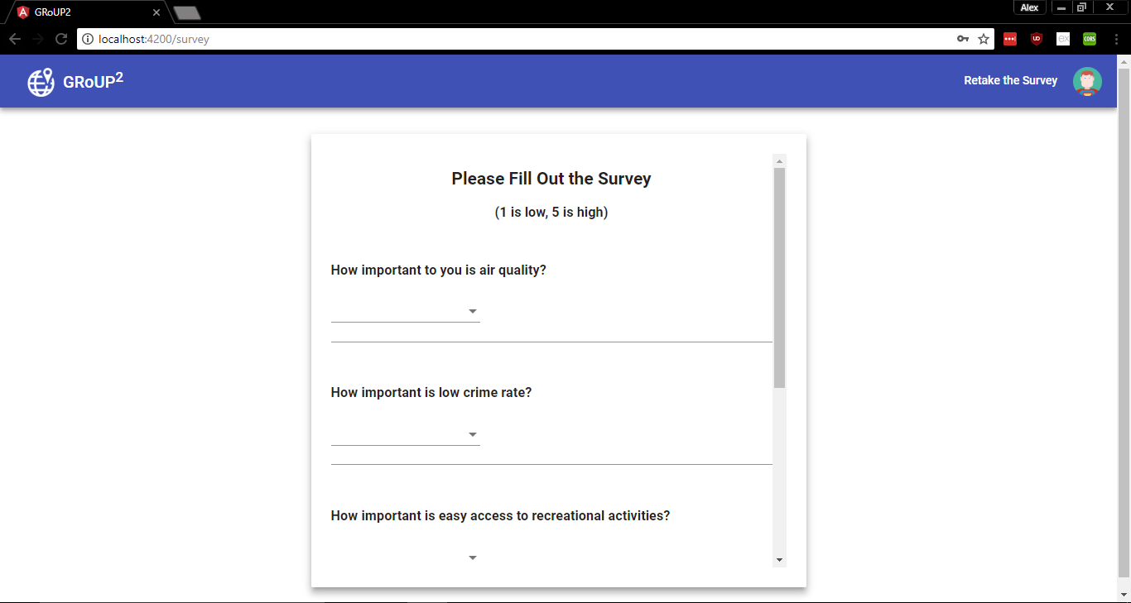  
 After taking the survey the user will be redirected to the homepage of the application. From here the map that was initially presented should have pins for the user’s top counties. Additionally, the counties will be in a list to the user on the homepage. The pins can be further clicked to prompt the user with an image and description of the location provided by Google. The updated homepage will be shown as below.

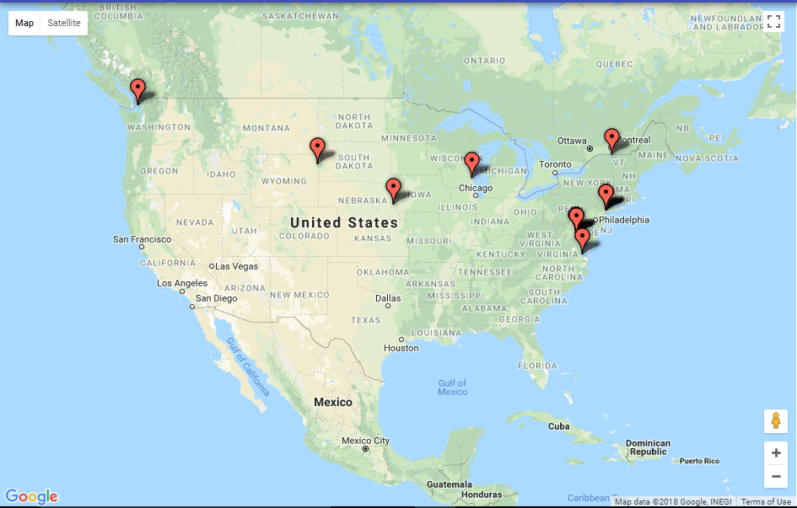

# Access to the software

## First-time user of the software

### Access control

The application does not have any hard setup needed to obtain a username or password. Part of the actual application is those which correspond to the creating of an account. The create account page is accessible from the initial login page. At this point the user will be prompted to enter their desired username and password. The only set username rules are that the username may not be NULL and the username must be unique. The user will be prompted with an error message for either of these issues. The layout of the create account page is shown below.

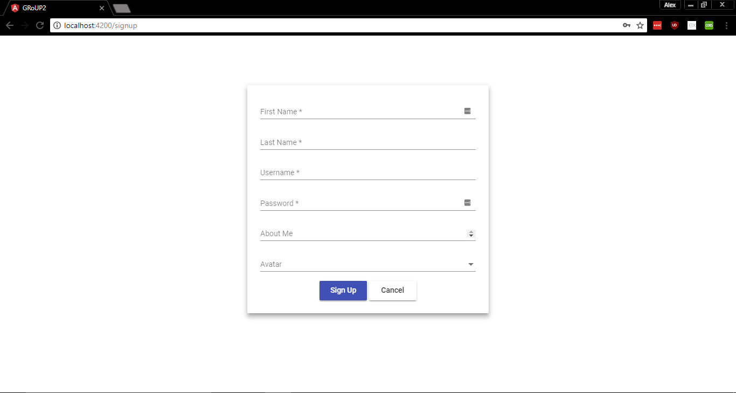

After creating the account, the user may then access the homepage of the system by logging in from the login page. This will check the username and password of the user account within the login database. If the user wishes to modify their account, they must access the modify account page accessible from the homepage of the application. These username and passwords must follow the same rules as those processed during the creation of the account. Any NULL fields will be assumed to not be changed. The modify account button located on the homepage is highlighted below.

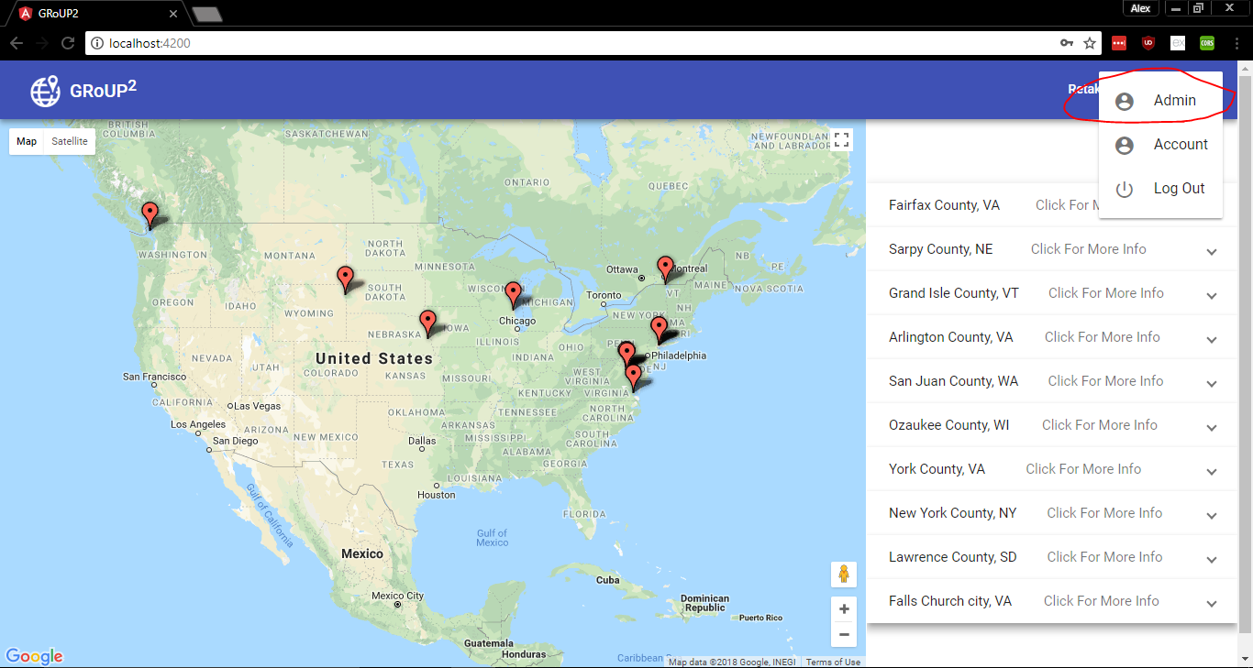

### Installation and setup

Setting up the software of the system was described within the Software Inventory section. Further information can also be found within the SETUP README file.

## Initiating a session

The basic setup for setting up a session can be found within the Software Inventory section. This procedure is posted below:

From the root directory, enter the frontend directory. Open a Windows PowerShell by holding shift and right clicking. From the list of options, click the “open PowerShell window here.” From here run the following commands:

npm install

npm run

This first command will install the dependencies for the system. The second command will open the site. Afterwards the website may be reached from localhost:4200. Further instructions on the setup process can be found within the SETUP README.

After the first setup, the user should be able to just enter the npm run command. If there are any issues it is recommended to run the npm install to ensure all files are up-to-date.

## Stopping and suspending work

If the user wishes to end their work on the web application, they may simply click the ‘X’ in the corner of their browser. If the user is in the middle of their survey the current progress will not be saved. The survey progress is saved after the submission has been made. Similarly, if the user is on the modify account page, the new account progress will not be updated until the page has been submitted. It is not recommended that the user exits the application while modifying their account information.

# Processing reference guide

## Capabilities

Most webpages move with either the submission of a page, or by clicking on a page button. These relationships are described below. The login page allows the user to move to the create account page by clicking the modify account button. The login page additionally allows the user access to the homepage after entering their username and password and submitting the page. The create account page allows the user to submit their account information by submitting the page. This will redirect the user to the homepage. The user can additionally access the login page by clicking the back button without creating the new account.

The homepage allows the user to move to the modify account page and the survey page. These are both accessible on both of their respective buttons. From the modify account page, after entering the new account information, the user can be redirected to the homepage by submitting the page. The user can be redirected to the homepage by clicking the back button. From the survey page the user can be redirected to the homepage by completing the survey and submitting the page. This will update their map visual. Similarly, the user can access the map without updates by clicking the back button.

## Conventions

There are currently no conventions associated with the system assuming the user has followed the proper setup procedure described in the Software Inventory and SETUP README.

## Messages

Error messages will be presented to the user in the case that the user has improperly completed the submission of a page. These are associated with the login page, create account page, modify account page, and survey page.

If the username or password for the user account is not stored within the login database an error message will be presented to the user while on the login page. The user can either attempt to login again if they have an account or create a new account.

If the username submitted on the create account page is not unique the user will be given an error message. The user should enter a different username at this point. If the password or username submitted on the create account page is NULL then the user will be given an error message. The user should enter a username or password for whichever field is currently NULL.

If the username submitted on the modify account page is not unique the user will be given an error message. The user should enter a different username at this point. The user may also keep their current username by leaving the field blank.

# Signatures

_______________________________________________________________

Client Signature

_______________________________________________________________

Group Representative Signature